Modules in Python

1. Create a custom module with functions to add, subtract, multiply, and divide two numbers.

Module mymath.py

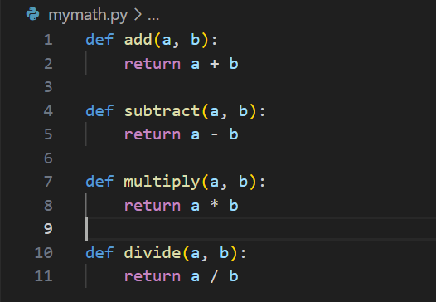

Calling the module

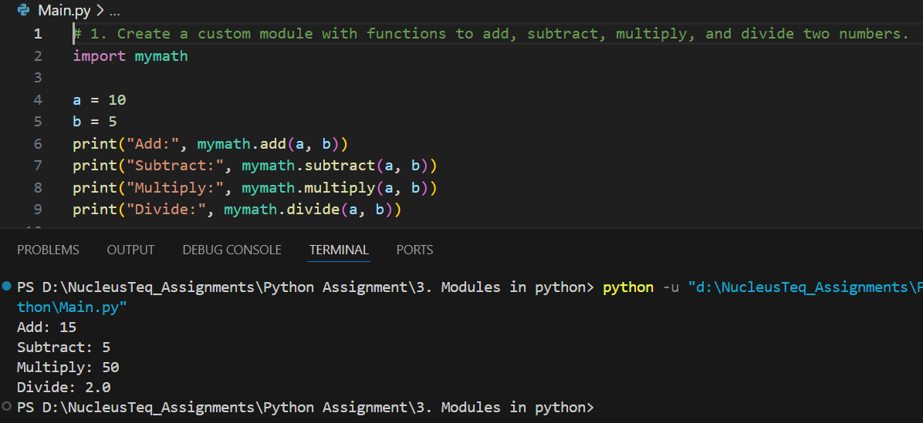

2. Use the `math` module to calculate square root, factorial, and power of a number.

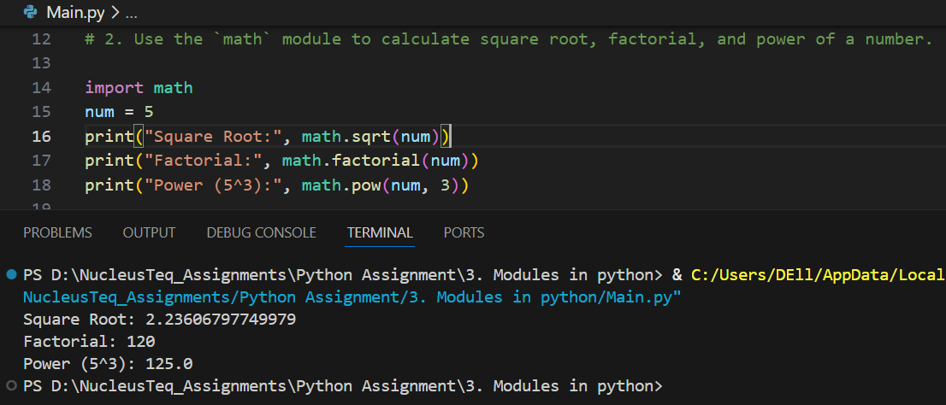

3. Write a program that uses `random` to generate a password of given length.

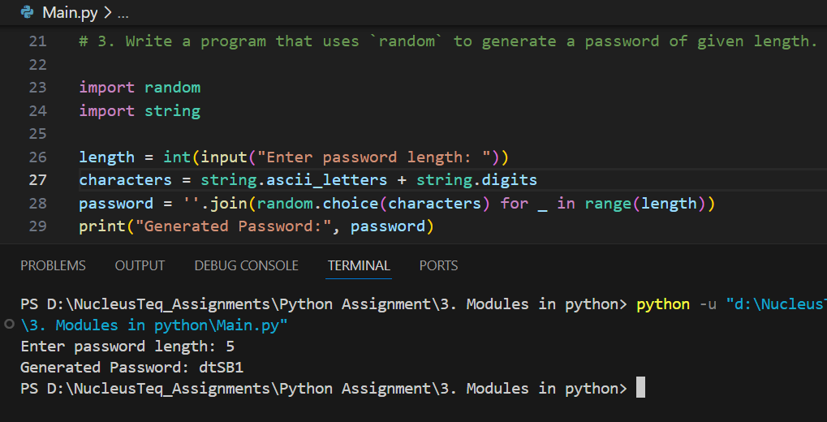

4. Create a program using the `datetime` module to display the current date and time.

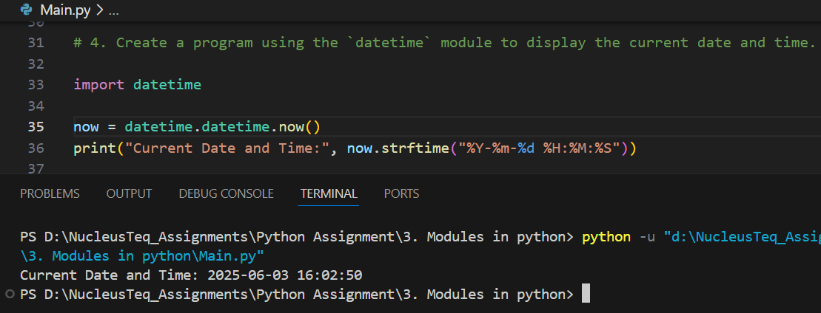

5. Import a custom module and use its functions in another script.

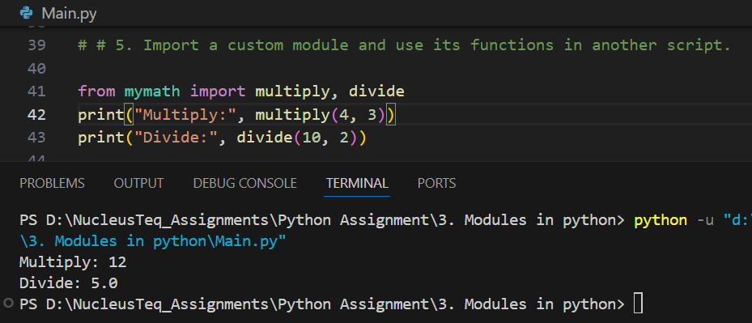

6. Build a command-line utility using `argparse` to perform arithmetic operations.

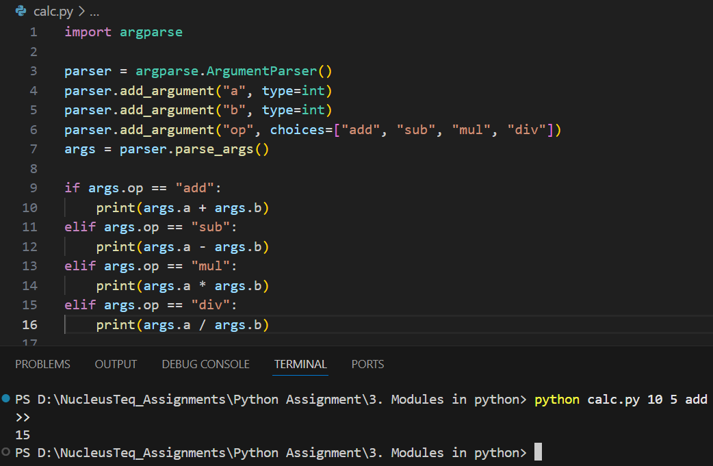

7. Create and use a package with multiple modules in it.

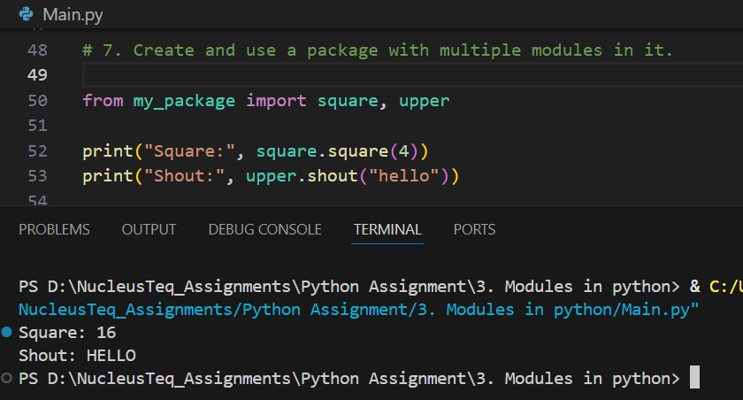

8. Develop a program that uses `os` and `sys` modules to list files and command-line args.

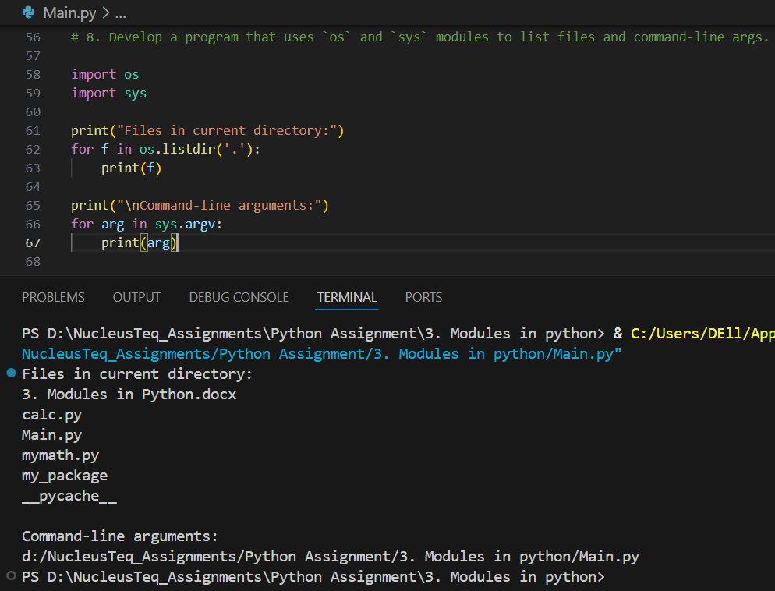

9. Use `importlib` to dynamically import a module and invoke a function.

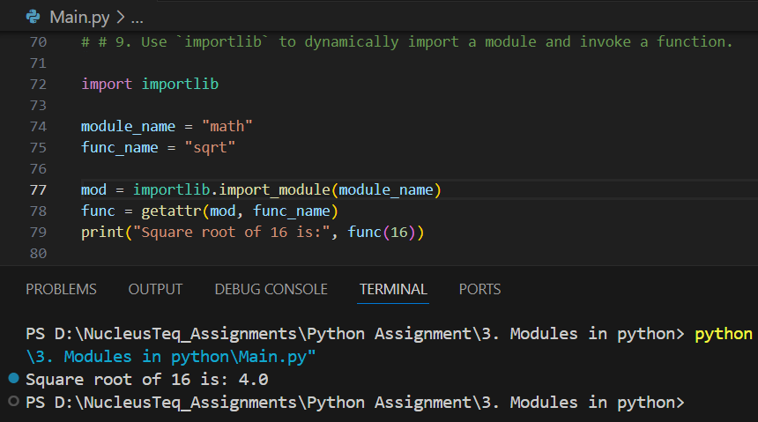

10. Implement a Python script that uses `glob` to search for all `.txt` files in a directory.

